|  |
| --- |
| CS-250 Software Development Lifecycle |
| Sprint Review and Retrospective |
| By Dalton Rose |

|  |
| --- |
|  |

During the completion of the SNHU Travel Project, our team utilized an agile methodology and the scrum framework to achieve our goals. Team members were required to take up various roles including product owner, scrum master, tester, and developer. Each of these roles played an important role in the completion of the project.

The product owner is responsible for communicating with the stakeholders, gaining an understanding of their needs, converting those needs into product requirements in the form of user stories, and choosing which features to prioritize. The product owner is important because they manage the trajectory of the project to meet the needs of the stakeholders. In my role as the project manager, I communicated with the client and a user research group in order to assess the needs of the project. After determining the needs of the project, I used that knowledge to make decisions about which features should be prioritized and developed user stories to be completed by the scrum team.

The scrum master is responsible for ensuring the team is following the scrum process by organizing scrum events like sprint planning, daily scrum meetings, backlog refinement, sprint review, and sprint retrospectives. The scrum master is important because these scrum events are crucial to the effectiveness of a scum team and enable the team to continuously iterate and adapt to evolving circumstances. In my role as the scrum master, I developed an agile team charter in order to define specific agile practices and scrum events that should be implemented to enable the team to work more effectively.

Testers are responsible for defining and implementing test cases to ensure the product is functioning properly according to the product requirements. Testers are important because they ensure the user stories brought into each sprint reach an acceptable level of functionality as described by the test cases. In my role as a tester, I used the requirements set forth in the user stories to develop a detailed set of test cases for the user stories to ensure everything met the requirements and that the program was functioning properly. In order to develop these test cases, it was necessary to communicate with the product owner to get clarification on some details about the project.

Developers are responsible for developing the product based on the specifications and requirements laid out by the product owner and scrum master. The developer is important because they are working to develop and deliver functionality to achieve the goals of each sprint. In my role as a developer, I worked to develop the product based on the project requirements. This involved updating the program to incorporate different travel destinations as the product requirements changed to focus specifically on health and wellness travel.

Throughout the software development lifecycle of the SNHU Travel project, the agile methodology and scrum framework contributed greatly to the success of the project. Using an agile approach, the team didn’t waste time coming up with detailed plans about every stage of the project development. Instead, the agile methodology enabled the team to more rapidly iterate and better adapt to changing product requirements. By dividing the work into smaller bite-sized chunks in the form of user stories, it was easier for the team to gain a better understanding of the tasks, plan for the needed functionality, and deliver results more rapidly.

Using the principles of agile and scrum, the team was able to quickly adapt to the change in product requirements for the SNHU Travel project. After developing the first version of the product, the product requirements changed in that the product changed from a list format to a slideshow format. The agile methodology was valuable in that we were able to get feedback from the client early and adapt the requirements of the products to meet their needs. Later on in the project development, the product requirements were changed again to incorporate health/wellness travel destinations as specified by the client. An agile methodology allows flexibility for the team to adjust the plan and workflow to adapt to changes and thanks to this, the team did not struggle to incorporate these new product requirements and develop the product.

The agile methodology and scrum framework encourage more open and effective communication within the team. Daily stand-up meetings are one effective way that the team can easily communicate the status of the tasks they are working on and request assistance from other team members to overcome blockers. Information radiators are another valuable communication tool that enables the team to get the latest information about the status of the project at a glance. Sprint reviews and retrospectives allow the team to voice their feedback on the results of the sprint and collaborate to identify ways in which the team could work together more effectively in the next sprint.

While working on the SNHU Travel project, it was necessary to communicate with other members of the team to gain a better understanding of the product requirements. For example, when developing test cases when acting as a tester, I found that a few of the details about the product requirements were vague. While I was unable to have a face-to-face meeting with the product owner, I did communicate with them via email to seek clarification. In the included email to the product owner Christy, I asked for clarification about those points. I kept the email brief and utilized bullet points so that my questions could be digested more quickly by the reader.

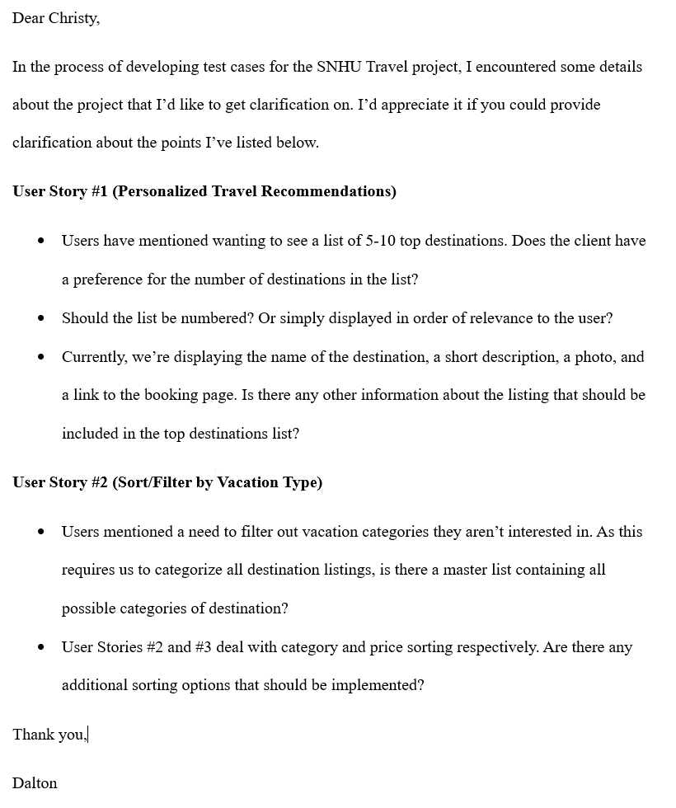

Overall, I believe the agile methodology and scrum framework were critical in the success of the SNHU Travel project. Utilizing agile and scrum allowed us to deliver a more satisfying product to the client. The advantages of agile during this project include increased adaptability, more effective and open communication, faster iteration, increased collaboration, and sustainable development. For this project, I think the only disadvantage of an agile methodology was that it wasn’t entirely clear what the final product would look like. In comparison to the waterfall methodology that ChadaTech used in the past, I think the agile methodology enabled the team to collaborate more effectively and deliver a better product for the SNHU Travel project. While similar results may have been possible with another methodology, a lot of time and resources would likely have been wasted without the efficiency granted by using an agile approach.